No.
Title: | DCCA-GS:Decoder-Reproducible Content-Adaptive Compression for Anchor-Hash 3DGS
Meeting
Date/Place:

Abstract
3D Gaussian Splatting (3DGS) achieves high-quality real-time novel-view rendering with explicit Gaussian primitives, but the per-primitive storage of geometry, covariance, opacity, and appearance grows rapidly with scene scale, making storage and transmission a deployment bottleneck for large-scale UAV and multi-view capture. This contribution describes DCCA-GS (Decoder-Reproducible Content-Adaptive Compression for Anchor-Based 3D Gaussian Splatting), built on the HAC++ anchor-hash entropy-coding framework. DCCA-GS keeps the HAC++ main pipeline (structured anchors, hash-grid context, conditional entropy model, arithmetic coding, G-PCC geometry) and adds four evaluated components: (1) decoder-reproducible content-adaptive formula quantization (I2), in which every quantization step is recomputed on both ends from a 4-dimensional descriptor of decoder-reconstructable structural quantities, so no per-anchor step data is transmitted; (2) a training-only render-sensitivity supervision (I6) that steers the complexity network without changing the bitstream; (3) mixed-precision post-training quantization of the decoder MLPs, with a per-group bit-width assignment derived from per-MLP sensitivity ablations, charged to the reported size; and (4) training-side anchor sparsity with ADMM projection (SPA), which imposes a hard anchor budget during training and re-adapts the surviving anchors under that budget, defining a low-rate operating point (74% size reduction at 0.84 dB PSNR cost on Deep-Blending playroom at 110k). Components (1) and (2) are jointly designed; their interaction is analyzed in the ablation study, where I6 is critical at low-rate SPA points (+0.42 dB). On the 4-28 UAV scene, the 110k-iteration operating point with MLP quantization reaches 28.82 dB PSNR at 5.49 MiB decode-required size, versus 28.31 dB at 6.95 MiB for the paper-reported HAC++ point on the same scene; on Deep Blending, playroom reaches 30.73 dB at 4.22 MiB and drjohnson 30.04 dB at 6.85 MiB. We also report quantitative analyses of codec efficiency (actual/estimated bits close to 1.0), a KL-redundancy lower bound for the scaling field, bitstream composition, rate-distortion behavior over lambda and training steps, and documented negative results (context conditioning below 2.3%, residual coding, and sensitivity side information). All bitstreams pass bit-exact standalone decoding verification.

Introduction
3DGS represents a scene with a large number of anisotropic Gaussian primitives and renders them through a visibility-aware splatting pipeline. The explicit attribute storage makes model size grow quickly with scene scale. UAV aerial surveys, indoor multi-view captures, and museum-scale reconstructions all exhibit large spatial extent combined with fine local detail, which is exactly the regime in which storage and bandwidth dominate deployment cost. Beyond compression ratio, a practical solution must be decoder-self-contained, bit-exactly reproducible, and efficient at inference time.
Anchor-based representations such as Scaffold-GS generate view-adaptive Gaussians from sparse anchors and remove inter-primitive redundancy. HAC and HAC++ go further: they model the joint distribution of anchor attributes with a conditional entropy model built on a multi-resolution hash grid and entropy-code the quantized symbols. HAC++ is the reference framework of this contribution. DCCA-GS keeps the Anchor-Hash main pipeline and its mask-aware probability factorization, and concentrates changes on three surfaces with separable effects: the quantization step, the training objective, and the transmitted model itself.

The two training-side modules are labeled I2 and I6 following our internal development taxonomy (I1 hierarchical context and I5 VQ were explored and are not part of the recommended configuration); the numbering is historical, and only the retained modules are described here.
Our contributions are as follows.
1. Decoder-reproducible content-adaptive formula quantization (I2). Quantization steps are generated on the fly from a 4-dimensional descriptor of decoder-reconstructable structural quantities—local anchor density, predicted scaling anisotropy, predicted offset energy, and active mask ratio. The bitstream carries no per-anchor step array, and training uses a straight-through estimator so that training, encoding, and decoding share the same quantization path. I2 is most effective when combined with I6 (Section 3.4); isolated-I2 conclusions are avoided at low-rate SPA operating points.
2. Render-sensitivity supervision (I6). The complexity network is trained to match a bounded, exponentially smoothed target derived from render-loss gradient norms; this affects training only and adds zero side information. Its high-rate gain is modest (about 0.1 dB), but it becomes critical in the low-rate SPA regime, where removing it reduces PSNR by 0.42 dB (see Section 3.4).
3. Mixed-precision MLP weight quantization. We apply per-output-channel symmetric post-training quantization with static arithmetic coding. The bit-width assignment is not uniform: the complexity and deform networks are quantized to 8 bits, while the opacity, covariance, color, and grid networks remain at 16 bits. This assignment is derived from per-MLP sensitivity ablation: 8-bit opacity directly degrades rendering, and 8-bit grid degrades the entropy model and increases attribute rate, whereas complexity/deform tolerate 8 bits with negligible loss.
4. Training-side anchor sparsity (SPA). Unlike encode-side top-k pruning, SPA imposes a hard anchor budget during training via ADMM projection and a linear budget ramp anchored to the historical maximum anchor count, allowing surviving anchors to re-adapt under the budget. At equal anchor count it outperforms encode-side top-k pruning by 5.5 dB, and the resulting operating point trades 0.84 dB PSNR for a 74% size reduction relative to the non-SPA model (see Section 3.4).
In the implementation and experiments, components (1) and (2) are referred to as I2 and I6, respectively; they are jointly designed, and their interaction is analyzed in the ablation study. All experiments follow a strict bitstream contract with standalone decoding verification and quantitative analyses of where the bits go and how much redundancy remains; this constitutes the evaluation protocol of this work rather than a separate technical contribution.

Method Description

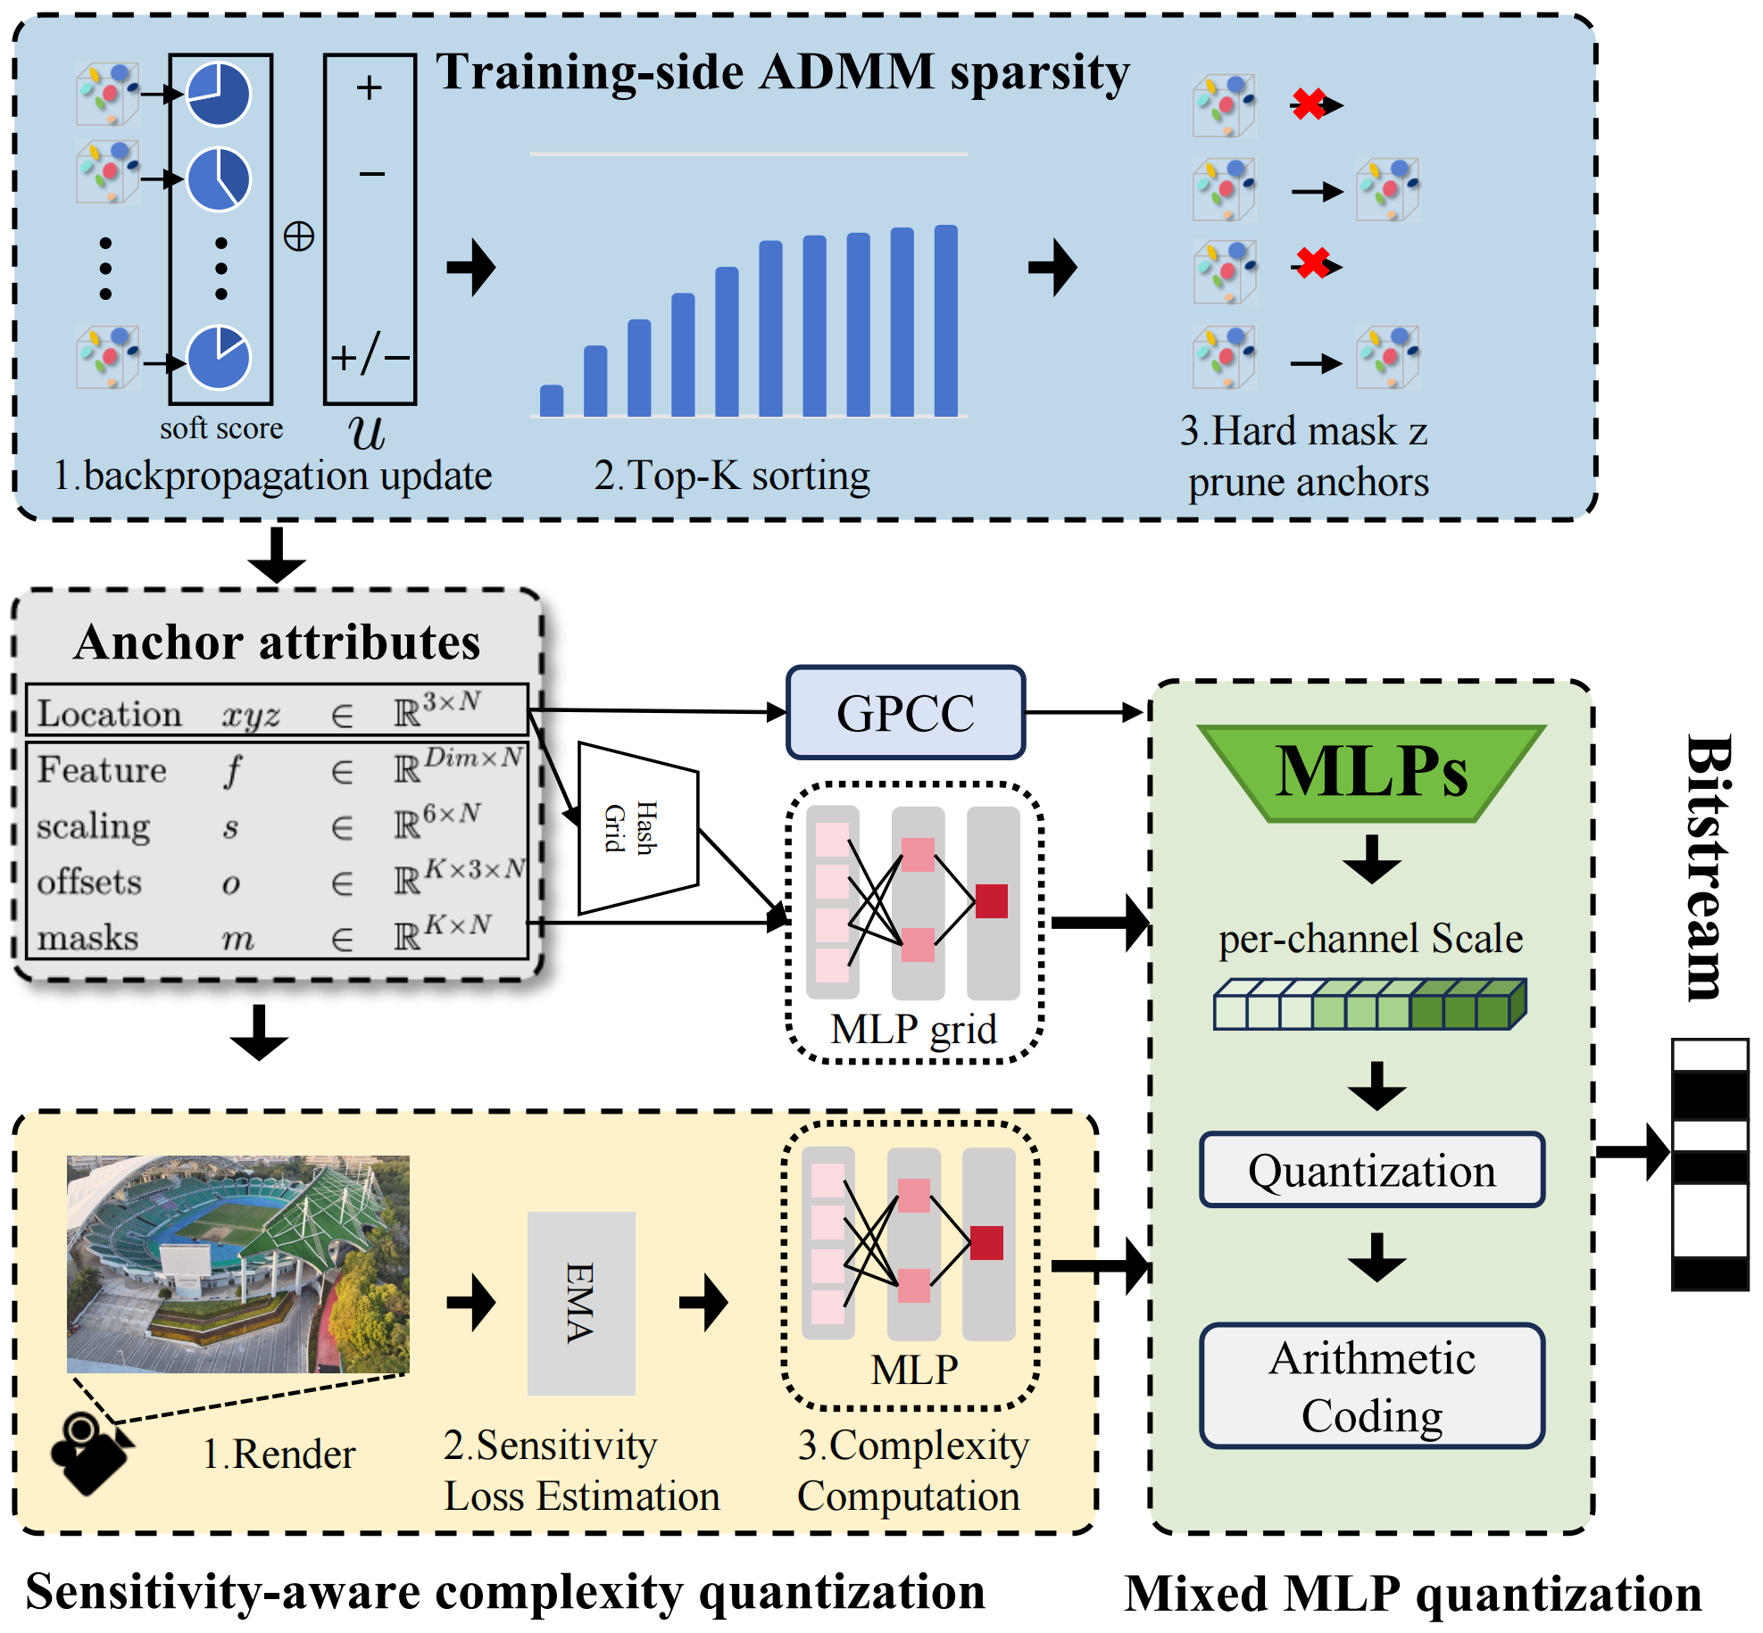
2.1 Baseline: HAC++ Anchor-Hash Codec
For the i-th anchor, x(i) denotes its position, f(i) its feature, s(i) its scaling, and o(i,k), m(i,k) denote the k-th candidate offset and its learned mask, with K = 10 offsets per anchor and feature dimension 50. The mask-aware entropy model factorizes the attribute joint distribution so that masked offset dimensions are not coded. The probability of a quantized symbol is obtained by integrating the modeled density over its quantization cell; an integer-CDF arithmetic coder writes the symbols. Anchor coordinates are coded with G-PCC (tmc3); hash-grid parameters are STE-binarized and coded with a Bernoulli model. The conditioning vector is produced by a multi-resolution hash grid followed by mlp_grid, which predicts per-field mean, scale, mixture weight, and base quantization logits qa/qs/qo.
The training objective is

$$\text{L}\text{ = (1−}\text{β}\text{) }\text{L}\text{1 + }\text{β}\text{ (1−}\text{SSIM}\text{) + }\text{η}\text{ ⋅}\text{scalereg}\text{ + }\text{λ} \frac{\text{R}}{\text{Nθ}}$$

$$\text{wit}\text{h }\text{β}\text{=0.2 }\text{and} \text{η}\text{=0.01}$$

lambda controls the rate-distortion trade-off. Training, encoding, and decoding share the same conditional model and quantization path, which is the basis of bit-exact reproducibility.

2.2 Decoder-Reproducible Content-Adaptive Formula Quantization
Uniform quantization cannot serve flat and detailed regions equally. DCCA-GS computes the step for field t as

$${\text{Q}}_{\text{t}}\text{=}{\text{Q}}_{\text{0,t}}\text{⋅(1+}\text{tanh}{\text{(}}{\text{z}}_{\text{t}}\text{)⋅α)}$$
$$\text{Q_0 = (1.0, 0.001, 0.2).}$$

for feature, scaling, and offset, and alpha = 0.35. The logits z_t come from a small complexity network mlp_complexity whose input is an 4-dimensional descriptor: local anchor density, predicted scaling anisotropy, predicted offset energy and active mask ratio. All four structural quantities are recomputed by the decoder from anchor coordinates, mlp_grid outputs, and already-decoded masks; therefore the steps are bit-exactly reproducible and the bitstream contains no per-anchor step array. Formula quantization is enabled after iteration 20,000 and ramped over the following 10,000 iterations; quantization uses a straight-through estimator during training. The best network width is 32 with one hidden layer (h32); the h25 variant is 0.018 dB worse on 4-28 at 90k iterations (28.637 vs 28.655 dB).

2.3 Render-Sensitivity Supervision
The multiplier target for the complexity network is derived from per-anchor render-loss gradient norms accumulated with an exponential moving average $\text{EMA(α=0.99)}$.The normalized target is $\text{(1+strength·tanh(−}{\text{z}}_{\text{score}}\text{))}$
, where ${\text{z}}_{\text{score}}$ uses relative normalization
$${\text{z}}_{\text{score}}\text{=clamp(}\frac{\text{EMA−mean}}{\text{mean}}\text{)}\text{ , }{\text{z}}_{\text{score}}\text{∈\{0.1,2.0\}}$$
$\text{strength=1.0}$ and the supervision weight is $0.001$. The supervision starts at iteration 20000. I6 changes only the training objective; encode and decode still follow the I2 formula path, so no bitstream field is added. In recorded experiments, I6 contributes approximately 0.09~0.10 dB on 4-28 sence while leaving the bitstream unchanged.
2.4 Mixed-Precision MLP Weight Quantization
Decoder MLPs participate in the entropy model (mlp_grid, mlp_deform, mlp_complexity) and in rendering (mlp_opacity, mlp_cov, mlp_color). DCCA-GS quantizes each parameter tensor per output channel with a symmetric scale
$$\text{Q}\text{=round}\left(\frac{\text{w}}{\text{scale}}\right)$$
$$\text{scale=}\frac{\text{max}{\text{|}}\text{w|}}{{\text{2}}^{\text{b−1}}\text{−1}}$$
, and compresses the integer indices with a static 32-bit arithmetic coder (raw int16 for 16-bit groups). The recommended map is complexity and deform at 8 bit and the remaining groups at 16 bit. Because the dequantized weights are used by the codec on both ends, the attribute bitstream is regenerated after quantization and the compressed MLP payload replaces the float32 accounting in the reported size.

2.5 Training-Side Anchor Sparsity with ADMM Budget
DCCA-GS's anchor mask provides a soft per-anchor score $a = mean(mask)$. SPA adds two training-only tensors, a binary hard mask z and a multiplier u, and every 100 iterations performs the ADMM update $\text{z=TopK(a+u,κ)}$, $\text{u = clamp(u + a - z, -1, 1)}$. The budget is $\text{κ=round(max(}{\text{N}}_{\text{r}\text{ef}}\text{)∗rati}{\text{o}}_{\text{t}}\text{)}$,with $\text{rati}{\text{o}}_{\text{t}}$ ramping linearly from 1.0 to the target ratio (e.g., 0.5) between the growth start and update_until; anchoring the budget to the maximum anchor count observed prevents the geometric collapse of a $\text{ratio}\text{∗}{\text{N}}_{\text{t}}$ schedule. The augmented loss term$\text{ ρ/2·‖a-z+u‖²}$（ρ=1e-3） is added to the training loss, and z replaces the heuristic opacity pruning while SPA is enabled. SPA state is never written to the bitstream.

Experimental Results and Analysis

3.1 Datasets & Configuration
Datasets. 4-28 is a large-scale UAV scene (1,200 images, 150 validation views under test_every = 8). Deep Blending provides playroom (225 images, 29 validation views) and drjohnson (263 images, 33 validation views), covering a different capture modality (hand-held, indoor, object-centric). Evaluation is performed on decoded bitstreams at 1600-pixel width with data_factor = 1 and test_every = 8. Metrics are PSNR, SSIM, and VGG-LPIPS. Sizes are decode-required payload in MiB.
Training protocol. The recommended configuration is I2 + I6, feature dimension 50, complexity hidden 32, voxel size 0.001, 10 offsets, appearance dimension 0, and 110,000 iterations with anchor growth stopped after 45,000. We report λ in {0.001, 0.002, 0.004}. Every result below is the decoded-view metric of the actual bitstream; the quantized column additionally applies the mixed-precision MLP quantization of Section 2.4.

3.2 Main Result
4-28 UAV scene. Table 1 presents the decoded-view comparison on the 4-28 UAV scene. DCCA-GS achieves the highest PSNR of 28.82 dB among all methods and the best average rank of 3.50. Compared with the same-framework baseline HAC++ (28.31 dB, 6.95 MB), DCCA-GS improves PSNR by 0.51 dB while reducing the required size by about 21%, demonstrating simultaneous gains in quality and compactness. Relative to uncompressed representations (3DGS and gsplat, about 612 MB), DCCA-GS attains roughly 111× compression while keeping SSIM (0.89) and perceptual quality (LPIPS 0.28) at the forefront of mainstream methods, with a footprint well below those of ContextGS (8.65 MB) and HAC (9.39 MB) in the same quality range, reflecting favorable rate–distortion performance and deployment efficiency.3.3 Experimental Results
Table 1.Decoded-view comparison on the 4-28 UAV scene (1,200 training images, 150 validation views at 1600-pixel width).
Method | Rank | 4-28
 |  | PSNR | SSIM | LPIPS | Size [MB]
ours(w Spa) | 3.50 | 28.82 | 0.89 | 0.28 | 5.49
CAT | 4.17 | 27.47 | 0.89 | 0.18 | 5.26
PC-GS | 5.33 | 27.32 | 0.89 | 0.30 | 5.04
HAC++ | 5.50 | 28.31 | 0.89 | 0.29 | 6.95
contextgs | 6.33 | 27.60 | 0.89 | 0.29 | 8.65
HAC | 7.67 | 27.60 | 0.89 | 0.29 | 9.39
TC-GS | 8.17 | 27.30 | 0.88 | 0.30 | 7.33
RDO-gaussian | 8.67 | 25.42 | 0.86 | 0.32 | 2.97
Scaffold-gs | 9.50 | 27.68 | 0.90 | 0.28 | 132.52
compact3d | 10.67 | 25.87 | 0.88 | 0.31 | 8.51
3DGS | 11.00 | 26.98 | 0.90 | 0.28 | 612.00
Minisplatting | 11.50 | 25.96 | 0.88 | 0.30 | 11.91
gsplat | 11.83 | 26.75 | 0.90 | 0.29 | 612.00
gaussianspa | 12.17 | 26.49 | 0.89 | 0.29 | 107.09
FC-GS | 12.83 | 20.57 | 0.81 | 0.22 | 38.37
compact3dgs | 13.33 | 25.98 | 0.87 | 0.31 | 32.37
Lightgaussian | 14.17 | 26.04 | 0.88 | 0.31 | 119.24
Octree-GS | 14.17 | 25.20 | 0.85 | 0.35 | 13.34

Deep Blending benchmark. Table 2 reports the cross-method comparison on Deep Blending. To make the comparison unambiguous, DCCA-GS is shown at two operating points: the high-quality point (I2 + I6 + MLP quantization, without SPA) reaches 30.73 dB PSNR, 0.913 SSIM, and 4.22 MB; the low-bitrate SPA point reaches 29.90 dB PSNR and 0.96 MB. Compared with HAC++ highrate (30.93 dB, 4.56 MB), the high-quality point achieves nearly identical quality while reducing the size by about 7.5%; compared with ContextGS highrate (30.93 dB, 5.67 MB), it is about 25.5% smaller at comparable quality. The low-bitrate SPA point extends the operating range to sub-1 MiB while remaining competitive with low-bitrate baselines. Note that Table 3 in Section 3.3 reports DCCA-GS’s own λ sweep on Deep Blending, whereas Table 2 is the cross-method comparison; the two tables should be read together but serve different purposes.

Table 2. Generalization study: comparison with state-of-the-art methods on Deep Blending. Sizes are decode-required payload in MiB. DCCA-GS is reported at both its high-quality operating point (I2+I6 + MLP quantization, without SPA) and low-bitrate operating point (I2+I6 + MLP quantization + SPA).
Method | PSNR | SSIM | LPIPS | Size (MB)
DCCA-GS (ours, high-rate) | 30.73 | 0.91 | 0.26 | 4.22
DCCA-GS (ours, low-rate SPA) | 29.90 | 0.90 | 0.31 | 0.96
HAC++ highrate | 30.93 | 0.91 | 0.26 | 4.56
HAC++ lowrate | 30.69 | 0.91 | 0.27 | 2.54
HAC highrate | 30.84 | 0.91 | 0.26 | 5.28
HAC lowrate | 30.44 | 0.90 | 0.27 | 3.31
ContextGS highrate | 30.93 | 0.91 | 0.27 | 5.67
ContextGS lowrate | 30.51 | 0.91 | 0.27 | 3.13
Smol-GS large | 30.67 | 0.91 | 0.26 | 2.96
Smol-GS base | 30.62 | 0.91 | 0.26 | 2.39
CompGS | 29.61 | 0.89 | 0.31 | 5.30

3.3 Rate-Distortion and Lambda Analysis
Table 3.Decoded-view results of DCCA-GS on Deep Blending under different rate–distortion trade-off parameters λ.
Scene | lambda | PSNR | SSIM | LPIPS | Size
playroom | 0.001 | 30.6624 | 0.9137 | 0.2531 | 5.8024
playroom | 0.002 | 30.7288 | 0.913 | 0.2575 | 4.2231
playroom | 0.004 | 30.619 | 0.9103 | 0.2632 | 3.0072
drjohnson | 0.001 | 30.0934 | 0.9124 | 0.2409 | 9.6294
drjohnson | 0.002 | 30.0376 | 0.9112 | 0.2459 | 6.8549
drjohnson | 0.004 | 30.0443 | 0.91 | 0.2521 | 4.7625

Table 3 examines the rate–distortion behavior of DCCA-GS under different λ. As λ increases from 0.001 to 0.004, the decode-required size of playroom and drjohnson smoothly decreases from 5.80 MB and 9.63 MB to 3.01 MB and 4.76 MB, respectively, while PSNR remains highly stable within 30.62–30.73 dB and 30.04–30.09 dB. These results show that DCCA-GS provides smooth and controllable bitrate switching with virtually unchanged quality, offering flexible operating points for diverse bandwidth conditions. For example, at λ = 0.004, playroom retains a strong PSNR of 30.62 dB—close to its best value of 30.73 dB—while its size decreases by about 48% relative to the highest-rate setting, illustrating efficient use of the bit budget.

Fig. 1. Rate–distortion on Deep Blending: DCCA-GS with and without training-side SPA vs. state-of-the-art 3DGS compression.
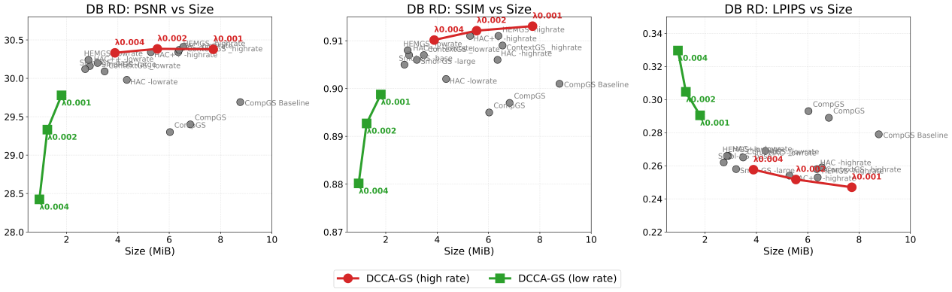
Figure 1 compares the rate–distortion performance of DCCA-GS against state-of-the-art 3DGS compression methods on Deep Blending, averaged over playroom and drjohnson. All DCCA-GS points include content-aware quantization, sensitivity-aware complexity prediction, and mixed-precision MLP quantization, and report the final decoded-required payload size. In the high-rate regime, DCCA-GS without SPA achieves 30.33 dB at 3.885 MiB under λ = 0.004, matching the 30.34 dB of HAC++ while reducing the bitrate by approximately 26%, and reaches 30.38 dB at 7.716 MiB under λ = 0.001, placing it on or slightly above the RD frontier established by prior work. The aggregate curve is smooth and monotonic: PSNR changes by less than 0.06 dB between λ = 0.001 and 0.002 while size changes by 2.16 MiB, indicating a rate-efficient high-fidelity regime. Mixed-precision MLP quantization shifts the curve left by roughly 0.16 MiB at every λ with a PSNR change below 0.004 dB, confirming that the model payload is a low-risk lever. At a slightly smaller size than HAC++ highrate (4.22 vs 4.56 MiB), DCCA-GS matches its SSIM and uses 71% fewer primitives, and it dominates CompGS on both rate and quality.
When training-side ADMM sparsity is applied, the method extends this curve into a substantially lower bitrate region: at λ = 0.002, the model size drops from 5.539 MiB to 1.257 MiB, a reduction of roughly 77%, with a corresponding PSNR decrease of about 1.05 dB; at λ = 0.004, the size reaches 0.947 MiB with 28.42 dB, entering a sub-1 MiB operating range that existing survey methods do not cover. Compared with low-bitrate baselines such as HAC++ (2.910 MiB, 30.16 dB) and Smol-GS (2.728 MiB, 30.12 dB), the SPA variant is approximately 38% smaller while remaining within 0.38 dB in PSNR. Consistent trends across PSNR, SSIM, and LPIPS confirm that the proposed system provides a smooth and monotonic RD trade-off, demonstrating that training-side ADMM sparsity, combined with mixed-precision MLP quantization and content-aware quantization, enables a continuous operating range from high-quality compression to extremely low bitrates. Protocol differences with the survey methods (splits, resolution, size conventions) mean the comparison is trend-level rather than a strict benchmark.

3.4 Ablation Study
To directly validate the contribution of each proposed component, we ablate SPA, I2, and I6 on Deep Blending playroom at 110k iterations and λ = 0.002. All variants in Table 4 use the float32 codec (without MLP quantization) and are evaluated on decoded bitstreams.
Table 4. Ablation of SPA, I2, and I6 on Deep Blending playroom (110k, λ = 0.002). ΔPSNR and ΔSize are relative to the full SPA model with I2 and I6 enabled.
Variant | PSNR | SSIM | LPIPS | size | ΔPSNR | Δsize
Full (I2+I6+SPA) | 29.8908 | 0.8963 | 0.3072 | 1.1292 | — | —
No SPA + I2 (w/o I6) | 30.6671 | 0.9123 | 0.2577 | 4.4668 | 0.7763 | 3.3376
No SPA (w/o I2/I6) | 30.7286 | 0.9129 | 0.2563 | 4.4143 | 0.8378 | 3.2851
No SPA (I2+I6) | 30.7310 | 0.9130 | 0.2575 | 4.3819 | 0.8402 | 3.2527
SPA + I2 (w/o I6) | 29.4691 | 0.8920 | 0.3209 | 0.9836 | −0.4217 | −0.1456
SPA only (w/o I2/I6) | 29.7623 | 0.8940 | 0.3162 | 1.0083 | −0.1285 | −0.1209

Enabling SPA is the dominant rate-reduction factor: it reduces the decoded payload from approximately 4.38 MB to 1.13 MB (≈74%) at a cost of 0.84 dB PSNR, and this behavior is consistent across all I2/I6 configurations. Within the SPA regime, I6 remains clearly beneficial: the full model outperforms SPA without I6 by 0.42 dB PSNR, albeit at a modest rate increase of 0.15 MB. In the non-SPA regime, I6 also improves PSNR by 0.064 dB while slightly decreasing rate, confirming its positive contribution independent of SPA.
The effect of I2 is more nuanced and configuration-dependent. Without SPA, enabling the I2+I6 combination yields essentially no PSNR change (+0.002 dB) with a small rate reduction, indicating that I2 alone contributes little on this scene. With SPA, the full model is 0.13 dB better than the SPA-only baseline, but the SPA+I2 (w/o I6) variant is 0.29 dB worse than SPA-only, revealing a strong interaction between I2 and I6 in the low-rate regime. This suggests that I2 should be reported jointly with I6, and that isolated I2 conclusions should be avoided in the low-rate SPA operating point.
.

Table 4 provides a field-level breakdown of the decode-required payload. Attribute fields—feature, scaling, and offsets—together account for about 82.8% of the total size, confirming that the bit budget is concentrated on content-carrying attributes, while hash parameters and bounds/header overhead account for less than 0.5% in total, indicating highly efficient bit allocation. MLP weights account for only 5.9% under the 32-bit accounting convention; after applying the 16/8-bit mixed-precision quantization and charging the actual compressed payload, the decode-required size is further reduced from 5.65 MB to 5.49 MB without introducing any side information, yielding additional compression gains from model quantization.

3.5 Bitstream Composition Analysis
Table 5. Field-level breakdown of the decode-required payload on the 4-28 scene (110k iterations).
Field | Bits | MiB | Share
Feature | 23953808 | 2.8558 | 50.60%
Scaling | 9480704 | 1.1304 | 20.00%
Offsets | 5759376 | 0.6868 | 12.20%
Anchor geometry | 3768632 | 0.4494 | 8.00%
MLP weights (32-bit) | 2784704 | 0.332 | 5.90%
Masks | 1402480 | 0.1672 | 3.00%
Hash parameters | 213224 | 0.0254 | 0.45%
Bounds + header | 7,872+192 | 0.001 | 0.02%
Total | 47370992 | 5.6471 | 1

Table 5 provides a field-level breakdown of the decode-required payload. Attribute fields—feature, scaling, and offsets—together account for about 82.8% of the total size, confirming that the bit budget is concentrated on content-carrying attributes, while hash parameters and bounds/header overhead account for less than 0.5% in total, indicating highly efficient bit allocation. MLP weights account for only 5.9% under the 32-bit accounting convention; after applying the 16/8-bit mixed-precision quantization and charging the actual compressed payload, the decode-required size is further reduced from 5.65 MB to 5.49 MB without introducing any side information, yielding additional compression gains from model quantization.

4.Conclusion
This contribution proposes DCCA-GS, a comprehensive compression framework for anchor-based 3D Gaussian Splatting. By introducing decoder-reproducible content-adaptive quantization, render-sensitivity supervision, mixed-precision MLP quantization, and training-side ADMM sparsity, DCCA-GS achieves significant bitrate savings while maintaining high rendering fidelity. Extensive experiments on UAV and indoor scenes validate that the proposed method provides a smooth rate-distortion trade-off, pushing the compression ratio up to 111× with minimal quality loss. Future work will explore integrating this framework into real-time streaming pipelines.

Reference
[1] Kerbl B, Kopanas G, Leimkuhler T, et al. 3D Gaussian splatting for real-time radiance field rendering[J]. ACM Transactions on Graphics, 2023, 42(4): 139:1-139:14.
[2] Lu T, Yu H, Chen L, et al. Scaffold-GS: Structured 3D Gaussians for view-adaptive rendering[C]//CVPR. 2024: 20654-20664.
[3] Chen Y, Wu Q, Lin W, et al. HAC: Hash-grid assisted context for 3D Gaussian splatting compression[C]//ECCV. 2024.
[4] Chen Y, Wu Q, Lin W, et al. HAC++: Towards 100x compression of 3D Gaussian splatting[J]. arXiv:2501.12255, 2025.
[5] Wang Y, et al. ContextGS: Leveraging context for efficient 3D Gaussian splatting compression[J/OL]. 2024.
[6] Wang Y, et al. Smol-GS: Redundancy-aware scaling for 3D Gaussian splatting compression[J/OL]. 2026.
[7] Liu X, Wu X, Zhang P, et al. CompGS: Efficient 3D scene representation via compressed Gaussian splatting[C]//ACM MM. 2024.
[8] Liu X, et al. HEMGS: Hierarchical and efficient 3D Gaussian splatting compression[J/OL]. 2024.
[9] Liu X, Wu X, Zhang P, et al. GaussianSpa: An optimizing-sparsity framework for 3D Gaussian splatting compression[C]//CVPR. 2025. arXiv:2411.06019.
[10] Fan Z, et al. LightGaussian: Unbounded 3D Gaussian compression with 15x reduction and 200+ FPS[J]. NeurIPS, 2024.
[11] Navaneet K L, et al. Compact3D: Compressing Gaussian splat radiance field models with vector quantization[J]. arXiv:2311.18159, 2023.
[12] Girish S, et al. EAGLES: Efficient accelerated 3D Gaussians with lightweight encodingS[J]. 3DV, 2024.
[13] Niedermayr S, et al. Compressed 3D Gaussian splatting for accelerated novel view synthesis[C]//CVPR. 2024.
[14] Ma W, et al. 3D Gaussian Splatting compression survey[EB/OL]. https://w-m.github.io/3dgs-compression-survey/.
[15] Moffat A, Neal R M, Witten I H. Arithmetic coding revisited[J]. ACM Transactions on Information Systems, 1998, 16(3): 256-294.
[16] Schwarz S, et al. Emerging MPEG standards for point cloud compression[J]. IEEE Journal on Emerging and Selected Topics in Circuits and Systems, 2019, 9(1): 133-148.

Before submitting this contribution, please be sure to review the following IEEE copyright and patent policies:
IEEE Copyright Policy: https://standards.ieee.org/about/policies/bylaws/sect6-7.html#7
IEEE Patent Policy: http://standards.ieee.org/develop/policies/bylaws/sect6-7.html#6
and to complete the following questionnaire:
Copyright Permission
I, as the Submitter, am not aware of any copyright permissions needed for this document. | True False
If the answer is “False”, please:
- Contact the copyright holder to fill the following form with a valid digital signature or send the original form (download link: https://standards.ieee.org/content/dam/ieee-standards/standards/web/documents/other/permissionltrs.zip) to: Zhenxin Chen, No. 1 School of Computer Science, Guangdong University of Technology, University Town Campus, Guang Zhou, China. (Chinese: 广东工业大学大学城校区计算机学院，谢良，15521026769)
- OR, if the copyright is held by an organization (e.g. IEEE), please follow the steps described in: https://mp.weixin.qq.com/s/mAFw_gTus2PJOlMUGR2Piw and add the permission as an attachment file with this contribution.

<Copyright Holder>
<Street Address>
<City, State Zip>
<Date>
Name of the IEEE Standards Working Group Chair: Shan Liu
Name of the IEEE Standards Working Group: Volumetric Data Compression(C/DC/VDC)
Dear ,
I am authorized to grant permission to IEEE to use the material in connection with the IEEE Project noted below, including consensus ballot and public review of the material.
<IEEE Project Number, IEEE Project Title>
<Title, Author(s), Year of Publication, Copyright Holder>
<Page Number, Reference Number to Clauses, or pages to be Used, or Technical Area within the Document that is of Interest (Be as specific as possible)>
Non-exclusive, irrevocable, royalty-free permission to use this material is granted to IEEE for world rights distribution, with permission to reprint in all future revisions and editions of the resulting draft and approved IEEE standard, and in derivative works based on the standard, in all media known or hereinafter known.
Digital Signature:
<Date>
<Title>, <Affiliation>

The following acknowledgment requirements should be met:
Include an acknowledgment in the front matter and use the standard IEEE attribution footnote as shown:
<Material> reprinted with permission from <copyright owner>, <title of work from which material is excerpted>, © <copyright year>.
Include the specific attribution or front matter acknowledgment shown below:

Additional requirements are listed below:

Patent Claim
I, as the Submitter, am not aware of any patent claims that I may know, own, control, or have the ability to license that might be or become essential patent claims. | True False
If the answer is “False”, please fill the PDF in https://mentor.ieee.org/myproject/Public/mytools/mob/loa.pdf and send it to patcom@ieee.org, CC to LXie5201@outlook.com.

THE END OF THIS CONTRIBUTION

